UML Diagramm zur App: MK Ablesedienst

1..n

**ConnectServerTask**

~ localJsonArray : JsonArray

# doInBackground (var : Void…) : Void

**DataInputFragment**

- deviceCount : int

- currentDevice : int

- inputData: JsonArray

+ onCreate (savedInstanceState : Bundle) : void

+ setDeviceCount (count : int) : void

+ resetCount () : void

+ onCreateView (inflater: LayoutInflater, container : ViewGroup, savedInstanceState : Bundle) : View

- saveData () : void

- checkConnection () : Boolean

v

**ConnectServerTask**

~ localJsonArray : JsonArray

# doInBackground (var : Void…) : Void

**DetailPaneFragment**

- customerAppointment : CustomerAppointment

- deviceCount : int

- headline : TextView

+ onCreate (savedInstanceState : Bundle) : void

+ onResume() : void

+ onCreateView (inflater: LayoutInflater, container : ViewGroup, savedInstanceState : Bundle) : View

+ setCustomerAppointment ( customerAppointment : CustomerAppointment): void

- formatString (str : String) : String

**ContactFragment**

- customerAppointment: CustomerAppointment

+ onCreate(savedInstanceState: Bundle) : void

+ onCreateView(inflater: LayoutInflater, container: ViewGroup, savedInstanceState: Bundle) : View

+ onResume () : void

+ setCustomerAppointment(customerAppointment: CustomerAppointment) : void



**SettingsFragment**

+ onCreate (savedInstanceState : Bundle) : void

+ onCreateView (inflater: LayoutInflater, container : ViewGroup, savedInstanceState : Bundle) : View



**CustomAdapter**

- customerAppointments: List<CustomerAppointment>

- source: RecyclerViewFragment

~ CustomAdapter(customerAppointments: List<CustomerAppointment, source: RecyclerViewFragment): CustomAdapter

+ onCreateViewHolder(viewGroup: ViewGroup, viewType: int): ViewHolder

+ onBindViewHolder(holder: ViewHolder, i: int): void

+ getItemCount() : int

**RecyclerViewFragment**

# mRecyclerView : RecyclerView

# mAdapter : CustomAdapter

# mLayoutManager : RecyclerView.LayoutManager

- customerAppointments : List<CustomerAppointment>

- query : JsonArray

- emergencySaveInputData : JsonArray

+ onCreate (savedInstanceState : Bundle) : void

+ onResume() : void

+ onCreateView (inflater: LayoutInflater, container : ViewGroup, savedInstanceState : Bundle) : View

- createDataset (list : ArrayList<JsonObject>) : void

+ change(customer : CustomerAppointment) : void

- checkConnection () : Boolean

+ refreshHeadline () : void

+ setEmergencySaveInputData (arr : JsonArray) : void

**ViewHolder**

~ cv: CardView

- personName: TextView

- personAddress: TextView

- personTime: TextView

- view: View

~ ViewHolder(itemView: View) : ViewHolder

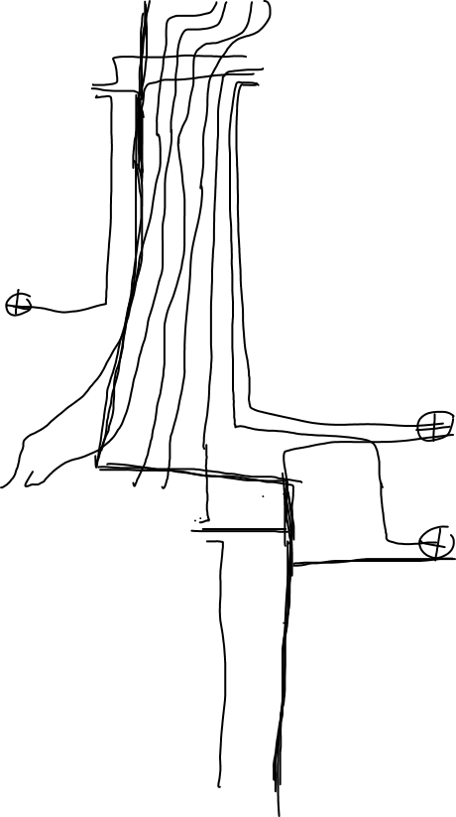

**ConnectServerTask**

~ localJsonArray : JsonArray

# doInBackground (var : Void…) : Void

**MainActivity**

# onCreate (savedInstanceState : Bundle) : void

+ onResume() : void

# transferButtons (transfer :String, customer : CustomerAppointment) : void

# setDataTransfer (count : int): void

+ onBackPressed () : void

+ onCreateOptionsMenu (menu : Menu) : boolean

+ onOptionsItemSelected (item : MenuItem) : boolean

+ onNavigationItemSelected (item : MenuItem) : Boolean

+ refreshHeadline () : void

+ goHome( item: MenuItem) : void

- goCalendar () : void

- goSettings () : void

**SendDataTask**

~ localJsonArray : JsonArray

# doInBackground (var : Void…) : Void

**CustomerAppointment**

- name : String

- address : Strimg

- addition : String

- zip : String

- city : String

- phone : String

- notes : String

- email : String

- mobile : String

- phoneBusiness : String

- emailBusiness : String

- id : String

- lt : LocalTime

~ CustomerAppointment(name: String, address: String, addition: String, zip: String, city: String, phone: String, notes: String, email: String, mobile: String, phoneBusiness: String, emailBusiness: String, time : String, id: String): CustomerAppointment

+ getId () : String

+ setName (name : String) : void

+ getName () : String

+ getAddress () : String

+ getAddition () : String

+ getZip () : String

+ getCity() : String

+ setPhone (phone: String) : void

+ getPhone () : String

+ getNotes () : String

+ getMobile () : String

+ getEmail () : String

+ getPhoneBusiness () : String

+ getEmailBusiness () : String

+ getTime () : String

- usefulString (str: String) : String

**UnscheduledFragment**

# mRecyclerView : RecyclerView

# mAdapter : UnscheduledAdapter

# mLayoutManager : RecyclerView.LayoutManager

- customers : List<CustomerAppointment>

- query : JsonArray

- customerAppointment : CustomerAppointment

+ onCreate (savedInstanceState : Bundle) : void

+ onResume() : void

+ onCreateView (inflater: LayoutInflater, container : ViewGroup, savedInstanceState : Bundle) : View

- createDataset (list : ArrayList<JsonObject>) : void

+ change(customer : CustomerAppointment) : void

- checkConnection () : Boolean

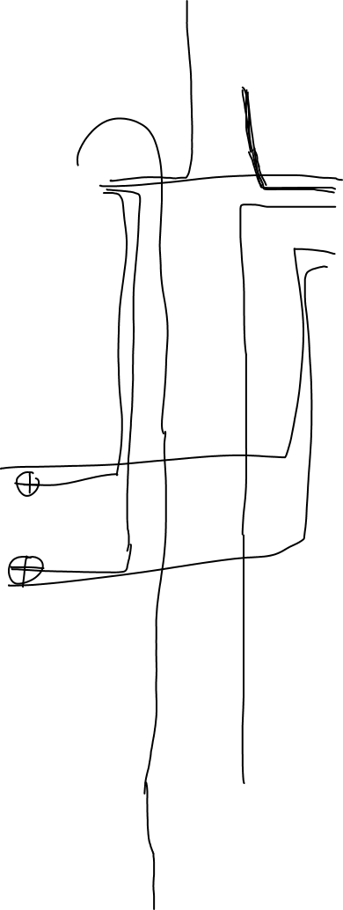

**ScheduleAppointmentTask**

# doInBackground (var : Void…) : Void

**ConnectServerTask**

~ localJsonArray : JsonArray

# doInBackground (var : Void…) : Void

**UnscheduledAdapter**

- customerAppointments : List<CustomerAppointment>

- source : UnscheduledFragment

~ UnscheduledAdapter (customerAppointments : List<CustomerAppointment>, source : UnscheduledFragment) : UnscheduledAdapter

+ onCreateViewHolder (viewGroup : ViewGroup, viewType : int) : ViewHolder

+ onBindViewHolder (holder : ViewHolder, i : int): void

+ getItemCount () : int



**ViewHolder**

~ cv: CardView

- personName: TextView

- personAddress: TextView

- personTime: TextView

- view: View

~ ViewHolder(itemView: View) : ViewHolder



1

0..n

**Server**

- socket: ServerSocket

+ main (args: String[]): void

**Appointment**

- appointID: String

- taskID: String

- taskTime: int

- status: int

- date: LocalDate

- start: LocalTime

- end: LocalTime

+ Appointment(appointID: String, date: String, start: String, end: String, taskID: String, taskTime: int, status: int) : Appointment

+ Appointment () : Appointment

+ getAppointID () : String

+ getTaskID() : String

+ getTaskTime () : int

+ getStatus () : int

+ getDate () : LocalDate

+ getStart() : LocalTime

+ getEnd () : LocalTime

+ setDate(date: LocalDate) : void

+ setStart(start: LocalTime): void

+ toString() : String

**Protocol**

- socket: Socket

- fromClient: ObjectInputStream

- toClient: ObjectOutputStream

- nr: int

- count: int

- resultSet: ResultSet

- jsonObject: JsonObject

- jsonArray: JsonArray

- userInput: String

- transferToClient: String

- connection: Connection

- statement: Statement

- gson: Gson

+ Protocol (s: Socket): Protocol

+ run (): void

- getCounterNumber (): void

- updateCounterHistory (): void

- findDateTime (appointmentList: List<Appointment>, toBeDated: Appointment): String

- basicQuery (): void

- undatedQuery (): void

- scheduleAppointment (): void

- formatString (str: String): String